

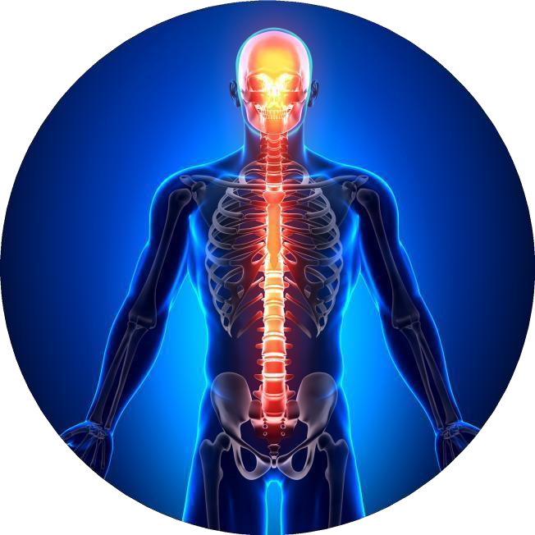


2026 MEMBERS IN GOOD STANDING

NEW BRUNSWICK CHIROPRACTORS ASSOCIATION
UPDATED: October 29, 2026



ALLABY | Robert | 74 | Active
ARMSTRONG | Corey | 220 | Active
ASOYUF | Shannon | 208 | Active
AUCOIN | Michel | 94 | Active
BARRETT | Meghan | 100 | Active
BATTAGLIA | Marie | 151 | Active
BELANGER | Rocko | 243 | Active
BERNARDI | Allison | 190 | Active
BERTHELOT | Caroline | 106 | Active
BIRD | John | 204 | Active
BITTING | Bruce | 51 | Active
BLANCHETTE | Michel | 42 | Active
BLAQUIERE | Vanessa | 217 | Active
BONAR | Jason F | 198 | Active
BOUDREAU | Adele | 199 | Active
BRAYALL | Scott | 176 | Active
BRIDEAU | Guillaume | 167 | Active
BROWN | Hollie | 197 | Active
BURCHILL | Samantha | 213 | Active
CARDENAS | Andrew | 174 | Active
CLARKSON | Jillian | 250 | Active
CLAYTON | Gerald "Todd" | 88 | Active
COATES | Rachelle | 175 | Active
COATES | Zachery | 206 | Active
COCHRAN | Matthew | 130 | Active
COLETTE | Emile | 238 | Active
COMEAU | Daniel | 142 | Active
CORMIER | Cedrick | 205 | Active
COSTER | Ryan | 161 | Active
COULOMBE | Brandon | 230 | Active
DESROCHES | Martine | 236 | Active
DICKSON | Dominique | 224 | Active
DOUCETTE | Stephen | 203 | Active

DRAKE | Jennifer | 102 | Active
DROST MURDOCK | Jody 'Melana' | 138 | Active
DROVER | Ashley | 222 | Active
DROVER | Michelle | 232 | Active
DUGUAY | Majorie | 112 | Active
DUNBAR | Shauna | 188 | Active
DUNNETT | David | 153 | Active
DUPAS | Didier | 179 | Active
DUPAS | Niki | 181 | Active
DUREPOS-OUELLETTE | Carole | 126 | Active
EVERETT | Haley | 177 | Active
FALLU | Daniel | 180 | Active
FLYNN | Laura | 140 | Active
FORGIE | David | 45 | Active
FORGIE | Matthew | 131 | Active
FORTIER | Kelly | 127 | Active
FORTIER | Jason | 128 | Active
GALEA | Stephanie | 196 | Active
GERVAIS | Dominik | 253 | Active
GILLIS | Stephen | 90 | Active
GLAZIER | Lynn-Ann | 103 | Active
GOBEIL | Veronica | 182 | Active
GOUDREAU | Natasha | 183 | Active
GOW | Shannon | 245 | Active
HACHÉ | Rene | 58 | Active
HANSON | Ryan | 228 | Active
HAYES | Michael | 216 | Active
HEBERT | Mathieu | 120 | Active
HERSEY | Jennie | 147 | Active
HOMES | Taryn | 237 | Active
HOWARD | Steven | 160 | Active
HUTT | Matthew | 137 | Active
JOHNSTON | Aaron | 92 | Active
JONES | Jenna | 193 | Active
JURCINA | Jacob | 234 | Active

KEENE | Alanna | 215 | Active
KENNEY | Mark | 67 | Active
KIMBER | Danny | 225 | Active
KLEIN | Erik F.C. | 119 | Active
LAFFOLEY | Rebecca | 209 | Active
LANDRY | Kamylle | 242 | Active
LANE | Marissa | 211 | Active
LEBLANC | Michel | 60 | Active
LEBLANC | Jean-Luc | 104 | Active
LEBLANC | Brett | 117 | Active
LEVERE | Carolyn Joy | 65 | Active
LEVESQUE | Martin | 187 | Active
LEVESQUE | Pierre | 71 | Active
LIRETTE | Lisa | 86 | Active
LUND | Melanie | 249 | Active
MACDONALD | Mallory | 251 | Active
MACMILLAN | Brandon | 162 | Active
MAGEE | Peter | 53 | Active
MARTIN | Frank | 132 | Active
MARTIN | Andrew | 244 | Active
MAYBERRY | Kayla | 170 | Active
MCKNIGHT-WHITFORD | Vanessa | 191 | Active
MCLEAN | Mallory | 246 | Active
MICHAUD | Wesley | 158 | Active
MIDDLEMISS | Sarah | 221 | Active
MORIN | Mathieu | 223 | Active
NEAL | John | 165 | Active
NISSEN | Kelsey | 178 | Active
NORTON | Graham | 152 | Active
OUELLETTE | Anne-Marie | 72 | Active
PARISIEN (Boyle) | Maria | 186 | Active
PARISIEN | Richard | 184 | Active
PATEL | Sima | 139 | Active
PENDELTON | Madison | 254 | Active
PIERS (Pelkey) | Lauren | 226 | Active

PLAGOS | Andrea | 241 | Active
POLLACK | Maxim | 148 | Active
POWER | Meagan | 252 | Active
POWER | Travis | 229 | Active
RAMSDALE | Theo | 218 | Active
RANDALL | Kathleen | 105 | Active
RICHARD | Lisa | 239 | Active
RIOUX | Caroline | 168 | Active
ROBICHAUD | Marie Josee | 68 | Active
ROBICHAUD | Louis-Marcel | 110 | Active
ROBICHAUD-LORDE | Miah | 172 | Active
SAVOIE | Mikael | 108 | Active
SAVOIE | Zachari | 240 | Active
SEABORN | Sarah | 231 | Active
SHEPPARD | Jeff | 85 | Active
SHORE | Michael | 210 | Active
SOLLY | Samantha | 235 | Active
SPENCER | Keli | 123 | Active
STOCKFORD | Baylee | 219 | Active
SWIM | Jacob | 201 | Active
SZOLOMICKI | Kristi | 227 | Active
TONER | Heather | 141 | Active
TROOP | Danielle | 248 | Active
WALLACE | Travis | 212 | Active
WALTON | Scott | 200 | Active
WILLIAMS | Matthew | 157 | Active
WILLIAMS | Sarah | 155 | Active
WILSON-MITTON | Coralee | 169 | Active

